SPRINT 1

|  |  |
| --- | --- |
| PROJECT NAME | Industry-specific intelligent fire management system |
| TEAM ID | PNT2022TMID50655 |

**Create IOT device config in IBM IOT Watson**

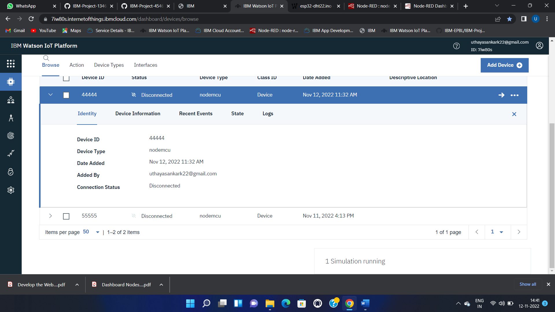

**Connected IBM IOT Watson cloud with wokwi (nodemcu)**

**Code:**

#include <time.h>

#include <WiFi.h>

#include <PubSubClient.h>

#define ORG "7iw80s"

#define DEVICE_TYPE "nodemcu"

#define DEVICE_ID "44444"

#define TOKEN "12345678"

char server[] = ORG ".messaging.internetofthings.ibmcloud.com";

char publishTopic[] = "iot-2/evt/data/fmt/json";

char authMethod[] = "use-token-auth";

char token[] = TOKEN;

char clientId[] = "d:" ORG ":" DEVICE_TYPE ":" DEVICE_ID;

WiFiClient wifiClient;

PubSubClient client(server, 1883, wifiClient);

float temperature = 0;

int gas = 0;

int flame = 0;

String flame_status = "";

String Gas_status = "";

String exhaust_fan_status = "";

String sprinkler_status = "";

void setup() {

Serial.begin(99900);

wifiConnect();

mqttConnect();

}

void loop() {

srand(time(0));

//initial variables and random generated data

temperature = random(-20,125);

gas = random(0,1000);

int flamereading = random(200,1024);

flame = map(flamereading,200,1024,0,2);

//set a flame status

switch (flame) {

case 0:

flame_status = "No Fire";

break;

case 1:

flame_status = "Fire is Detected";

break;

}

//send the sprinkler status

if(flame==1){

sprinkler_status = "Working";

}

else{

sprinkler_status = "Not Working";

}

//toggle the fan according to gas reading

if(gas > 100){

Gas_status = "Gas Leakage is Detected";

exhaust_fan_status = "Working";

}

else{

Gas_status = "No Gas Leakage is Detected";

exhaust_fan_status = "Not Working";

}

//json format for IBM Watson

String payload = "{";

payload+="\"gas\":";

payload+=gas;

payload+=",";

payload+="\"temperature\":";

payload+=(int)temperature;

payload+=",";

payload+="\"flame\":";

payload+=flamereading;

payload+=",";

payload+="\"fire_status\":\""+flame_status+"\",";

payload+="\"sprinkler_status\":\""+sprinkler_status+"\",";

payload+="\"Gas_status\":\""+Gas_status+"\",";

payload+="\"exhaust_fan_status\":\""+exhaust_fan_status+"\"}";

if(client.publish(publishTopic, (char*) payload.c_str()))

{

Serial.println("Publish OK");

}

else{

Serial.println("Publish failed");

}

delay(1000);

if (!client.loop())

{

mqttConnect();

}

}

void wifiConnect()

{

Serial.print("Connecting to ");

Serial.print("Wifi");

WiFi.begin("Wokwi-GUEST", "", 6);

while (WiFi.status() != WL_CONNECTED)

{

delay(500);

Serial.print(".");

}

Serial.print("WiFi connected, IP address: ");

Serial.println(WiFi.localIP());

}

void mqttConnect()

{

if (!client.connected())

{

Serial.print("Reconnecting MQTT client to ");

Serial.println(server);

while (!client.connect(clientId, authMethod, token))

{

Serial.print(".");

delay(500);

}

Serial.println();

}

}

